Special Interest Group 8: Motivation and Emotion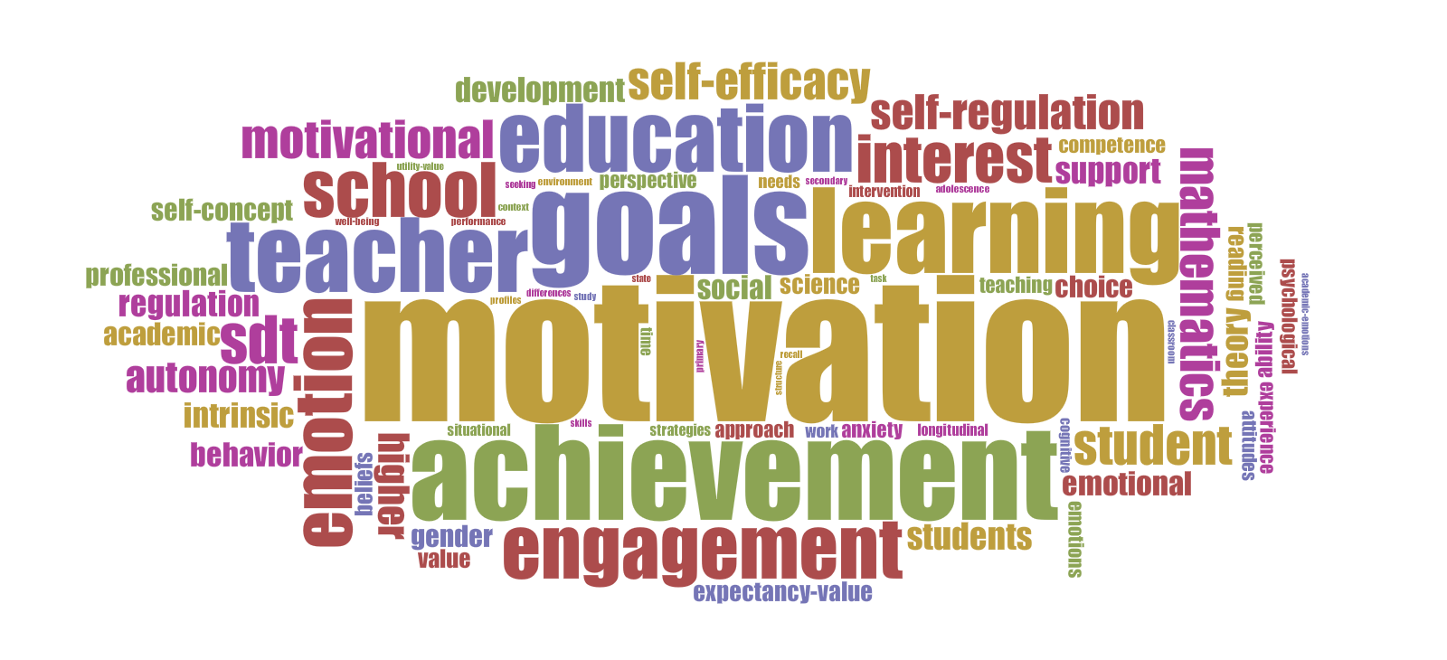
Newsletter  April 2017 | SIG 8 Motivation and Emotion  Coordinators:  Marina Lemos  marina@fpce.up.pt  &  Hanke Korpershoek  h.korpershoek@rug.nl

Dear SIG 8 members,
This newsletter includes important information concerning: (1) the selection of a SIG 8 Coordinator for the next four years, (2) the selection of a new SIG 8 JURE Assistant Coordinator for the next two years, (3) the call for the Student Research Excellence Recognition 2017, and (4) information on the ICM 2018 in Aarhus University, Denmark.

Call for new SIG 8 Coordinator
We are looking for new SIG Coordinator for the years 2017-2021 (4 years) to be nominated at EARLI 2017 conference in Tampere, as Marina Lemos will step down at the EARLI 2017 conference. The new SIG Coordinator will work together with SIG Coordinator Hanke Korpershoek and the new JURE Assistant Coordinator (to be nominated at EARLI 2017 as well).

All members of SIG 8 are invited to submit their candidacy or nominate a candidate (by e-mail to Marina Lemos (marina@fpce.up.pt). The coordinator should have been a member of the SIG Motivation and Emotion for the last four years. Being a SIG Coordinator involves responsibilities with regard to the organization of SIG activities such as the International Conference on Motivation, seminars, newsletters, the SIG website, and other publications. The SIG Coordinators are also the liaison between the members of the SIG and the EARLI Executive Committee and the EARLI office.

We hope that you will seriously consider applying for this position, as it is a great way to get involved in the research community of motivation and improve your professional network. Please send us the names, affiliation and contact information of yourself or others who might be interested. The deadline for these applications is May 31th, 2017.

Please keep in mind the regulations from EARLI: All EARLI members with a minimum of 4 years of membership and established research experience documented by a record of publications in a field of relevance to EARLI are eligible to stand for election as SIG Coordinator. The two SIG Coordinators need to work in different countries. No more than one coordinator can be non-European. More information about being a SIG Coordinator can be found at https://www.earli.org/sites/default/files/2016-10/SIG%20Policy%20Paper%20-%20for%20EC%20approval.pdf
You can also contact Hanke Korpershoek (h.korpershoek@rug.nl) with all your questions regarding the coordinator position of SIG 8.

In case there is more than one candidate, the election will be held via an online voting system prior to the EARLI 2017 conference. All SIG 8 members will be invited to cast their vote.

New SIG 8 JURE Assistant Coordinator
We are looking for a SIG 8 JURE Assistant Coordinator for the years 2017-2019 (2 years) to be nominated at EARLI 2017 conference in Tampere, as Kerstin Helker will step down.

All members of SIG 8 are invited to submit their candidacy or nominate a candidate (by e-mail to Marina Lemos (marina@fpce.up.pt). The JURE Assistant Coordinator should be a member of JURE at the start of his/her term. The JURE (Junior Researchers of EARLI) includes master and PhD students, as well as graduates who have received their doctorate within the last two years. We hope that you will seriously consider applying for this position, as it is a great way to get involved in the research community of motivation and improve your professional network. Please send us the names, affiliation and contact information of yourself or others who might be interested. The deadline for these applications is May 31st, 2017.

More information about being a SIG JURE Assistant Coordinator can be found at https://www.earli.org/sites/default/files/2016-10/SIG%20Policy%20Paper%20-%20for%20EC%20approval.pdf
You can also contact Kerstin Helker (Kerstin.Helker@rwth-aachen.de) with all your questions regarding the JURE Assistant Coordinator position of SIG 8.

In case there is more than one candidate, the election will be held via an online voting system prior to the EARLI 2017 conference. All SIG 8 members will be invited to cast their vote.

Student Research Excellence Recognition 2017
We are pleased to announce the fourth EARLI Motivation and Emotion SIG “Student Research Excellence Recognition” in conjunction with the 2017 EARLI conference in Tampere this year. The following principles and procedures govern the awards:
- Three “Student Research Excellence Recognition” will be presented at the biennial EARLI conference.
- Eligible students are those whose papers have been accepted at the EARLI conference, either as posters, individual papers, or papers as part of a symposium.
- The students or their supervisors must be members of the EARLI SIG Motivation and Emotion.
- The work must be related to Motivation and/or Emotion.
- Judgments will be based on an extended 2500 word abstract.
- The recognitions committee will consist of four SIG members.
- SIG Coordinators will select and chair the recognition committee.
- Each recognition designee will receive a certificate and will be invited to the SIG dinner.
- In the case of multiple authors, each student author will receive a certificate and be invited to the dinner.
- Recognitions will be announced and presented at the SIG members meeting.
- The awardees will give a short presentation (about 5 minutes) of their scientific work at the members meeting.

The recognition committee decision will be based on the following criteria:
- Innovative ideas, research question(s) and/or methods used
- Methodological rigor
- Quality of the description of the theoretical contribution of the research, practical implications of the research, and/or the contribution of the research to practice

Submissions of Abstracts should be accompanied by the attached application form by May 31st 2017 (17:00 GMT) to: marina@fpce.up.pt
We hope to receive a large number of submissions for these prestigious recognitions from our students and ask the members of our SIG to encourage their students to submit their work.

ICM 2018
ICM 2018 will be jointly organized by the EARLI SIG Motivation and Emotion and the Danish School of Education, 15th – 17th August, 2018 (Wednesday – Friday) at Aarhus University. Conference Chair: Niels Bonderup Dohn (dohn@edu.au.dk)
The Summer school will be held from 12th – 14th August 2018 (Sunday – Tuesday).

Kind regards,
Marina Lemos and Hanke Korpershoek (SIG 8 Coordinators)
Kerstin Helker (SIG 8 JURE Assistant Coordinator)

