Special Interest Group 8: Motivation and Emotion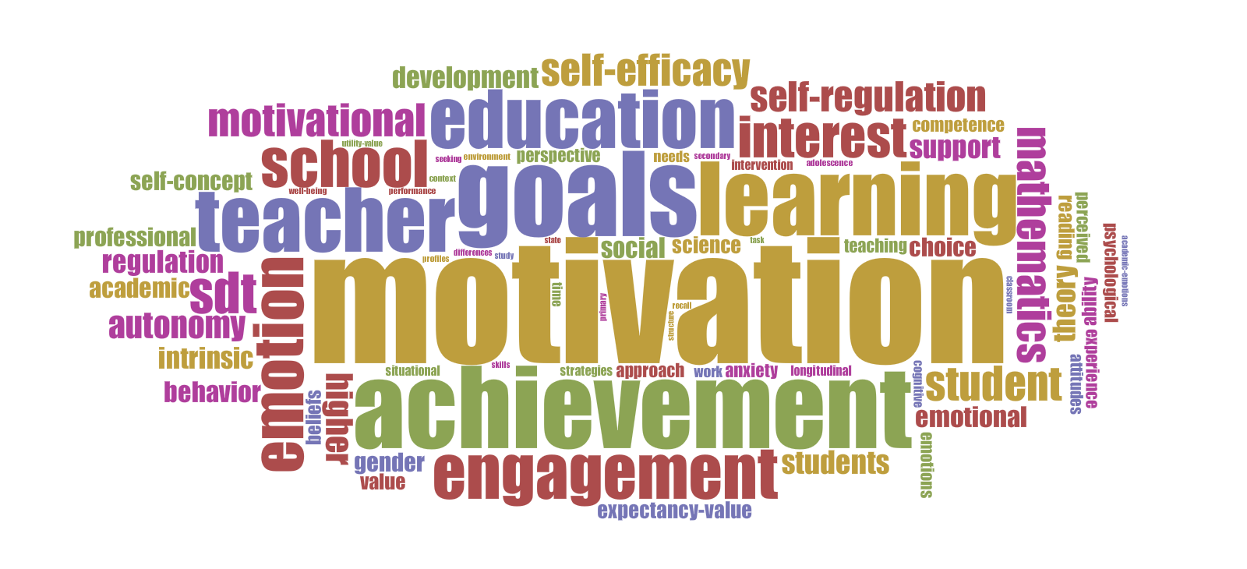
Newsletter  November 2016 | SIG 8 Motivation and Emotion  Coordinators:  Marina Lemos  marina@fpce.up.pt  &  Hanke Korpershoek  h.korpershoek@rug.nl

Dear SIG 8 members,
This newsletter includes a report on the SIG activities organized in the past year (2015/2016) and provides an overview of some future issues and activities.

ICM 2016
The ICM 2016, “The odyssey to the Ithaca of learning: Motivated persons, challenging contexts”, was held from August 24–27 at the Aristotle University of Thessaloniki, Greece. Chair: Eleftheria Gonida. The ICM conference included over 270 participants, 6 keynotes, 20 symposia, 96 papers, 40 posters, 1 expert panel session, and a pre-conference professional development workshop. The ICM summer school took place from August 22 to 24, and included 19 PhD students and 6 professors. Pictures can be viewed via de following link:
https://www.flickr.com/photos/87968369@N05/sets/72157675361775486

Life Time Achievement Recognition
“Life Time Achievement Recognition” was awarded to Anastasia Efklides and to Stuart Karabenick at the ICM in Thessaloniki. We congratulate them both with this very well deserved award. Take a look at the award ceremony via the ICM 2016 website:
http://www.psy.auth.gr/el/conference/main

Members Meeting 2016

The SIG 8 Motivation & Emotion Members Meeting at the ICM in Thessaloniki included the following topics:

Scope of Special Interest Group:
Analysis of the keywords, titles and abstracts of presentations at ICM, EARLI and JURE conferences 2010, 2013, 2014, 2015, using Voyant tools, was presented during the members meeting. The analysis showed that our SIG: (1) has a strong theoretical basis and (2) stands with a clear and distinct identity marked by:
- Main Topics Studied in educational contexts: Motivation; Emotion; Students; Teachers; Learning;
- Academic, behavioral, motivational and emotional variables: Achievement; Engagement; Interest; Needs.

New SIG Website (http://motivation-emotion.eu/):
A new SIG website was developed to increase the visibility of our SIG.
- The website itself offers historical information on our SIG, our mission statement, an overview of our (prior and future) activities, an overview of recent publication of SIG members. Soon to be included: previous newsletters, an pictures from ICM (current and previous).
- Social Media: During the members meeting the possibility to activate a Facebook or Twitter account was discussed. It was decided to ask this question in a members survey to reach all SIG members.

The Construct of Engagement:
Following the expression of a concern to find ways to better distinguish motivation constructs both theoretically and empirically, the organization of a task force was stimulated, to explore the construct of engagement to assess: (1) What the issues are, (2) Who the leading researchers are, and (3) Where they disagree or might find common ground. The task force with continue to work on this topic.

ICM 2018:
ICM 2018 will be jointly organized by the EARLI SIG Motivation and Emotion and the Danish School of Education, in August, week 33 (14th-20th August 2018) at Aarhus University. Conference Chair: Niels Bonderup Dohn (dohn@edu.au.dk)

Ideas for further SIG activities:
- A membership survey will be set up, to get more information on members’ wishes for future SIG communicative activities and exchange.
- A newsletter to young researchers to inform them about the activities of our SIG (has been sent and can be found on the new website).

EARLI Policy council
The EARLI Policy council meeting was held on the 9th of May 2016. The official minutes can be found in the members only section on the EARLI website.

Kind regards,
SIG 8 coordinators

