Special Interest Group 8: Motivation and Emotion

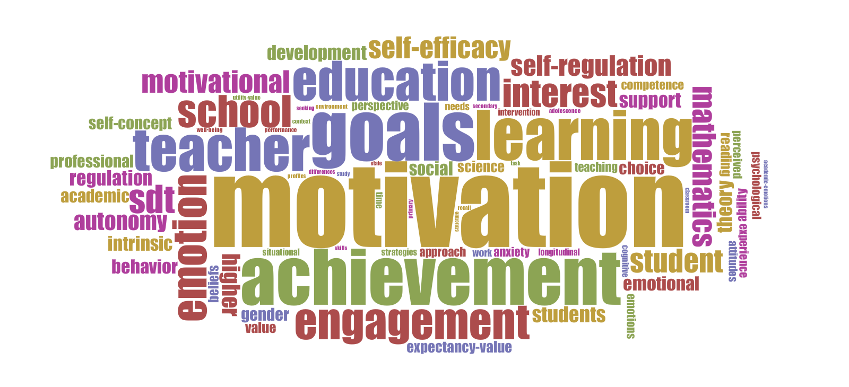
Newsletter  November 2017  Website SIG 8:  http://motivation-emotion.eu | SIG Coordinators:  Hanke Korpershoek  h.korpershoek@rug.nl  Fani Lauermann  fani.lauermann@uni-bonn.de  JURE Assistant Coordinator:  Kristina Loderer  Kristina.Loderer@psy.lmu.de | 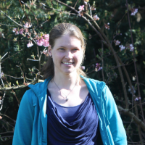
 |  | 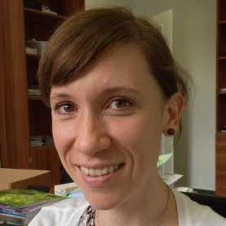
 |  | 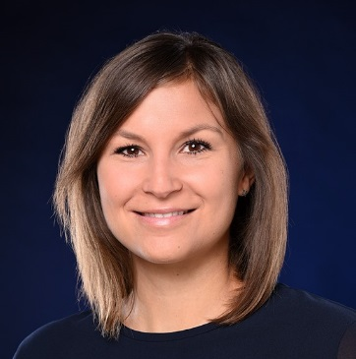

Dear SIG 8 members,
This newsletter includes interesting information concerning: (1) the introduction of a new SIG Coordinator and a new JURE Assistant Coordinator, (2) the next ICM conference and summer school in Aarhus, and (3) the 2017 Student Research Excellence Recognitions.

New SIG 8 Coordinator
At the members meeting at EARLI 2017 in Tampere, Finland, Fani Lauermann was elected as the new SIG 8 Coordinator for the next four years (2017-2021). Marina Lemos stepped down after completing her four-year term as coordinator. Fani will be working with Hanke for the next two years, until Hanke completes her term as senior coordinator of the SIG.

Fani Lauermann (Ph.D., University of Michigan) is an assistant professor at the University of Bonn and an affiliated researcher at the Institute for Social Research, University of Michigan-Ann Arbor. She has been an active SIG8 member since 2008. She studies motivational processes from the perspective of both teachers and students; broadly speaking, she is interested in (a) what motivates students to seek high quality education, and (b) what motivates teachers to provide such education. She was the recipient of the first EARLI SIG8 Student Research Excellence Award in 2010. Her research has also been distinguished with the 2011 Paul R. Pintrich outstanding paper award of the Motivation in Education SIG of the American Educational Research Association, and the 2013 Outstanding Author Contribution Award from the Emerald Literati Network for Excellence. In 2012, she was selected as one of the first two coordinators of the graduate student committee of the Motivation in Education SIG of AERA. Since 2014, she has been serving as an expert, an advisory board member and a technical consultant for the Center for Educational Research and Innovation of the Organisation for Economic Co-Operation and Development.

Fani introduces her selves below:
“I am grateful and honored to be nominated for the EARLI SIG8 co-coordinator position. The SIG8 International Conference on Motivation (ICM) was the very first international conference I attended even before I had started graduate school (in 2008), and I have been an active member of the SIG ever since. The SIG not only provides a platform for the showcase of cutting-edge research in the fields of motivation and emotion but also offers a rich and challenging intellectual environment as well as a supportive community, especially for young researchers. I have personally benefited from this support on multiple occasions, including the SIG8 Student Research Excellence Award, the emergence of interdisciplinary and international research collaborations, and the participation in innovative conference formats such as the first Spotlight Session at the ICM 2016, designed to highlight research contributions to a social issue of global (and European) importance.
I view my nomination for the EARLI SIG8 co-coordinator position as an exciting opportunity to both honor the SIG8 traditions and expand upon them. We, as a community, care deeply about the mentorship of young researchers, but also about the contributions of established SIG8 members; we care about the field of education not only as the target of our research efforts, but also about education as a social process and a way of living; we value diverse theoretical and methodological perspectives, because this diversity helps us to better understand how motivational and emotional constructs shape and are shaped by human behavior, and how we can create motivationally and emotionally supportive learning environments. I strongly identify with these values as a researcher and a member of the SIG and I am grateful to be part of and to be able to contribute to this community.”

New SIG 8 JURE Assistant Coordinator
At the members meeting at EARLI 2017 in Tampere, Finland, Kristina Loderer was selected as the new SIG 8 JURE Assistant Coordinator for the next two years (2017-2019), as Kerstin Helker stepped down after completing her two-year term.

Kristina Loderer is a postdoctoral researcher at the psychology department of the University of Munich in Germany, where she completed her doctoral studies in February 2017. She joined the SIG in 2015 when attending her first JURE and EARLI conferences in Limassol, Cyprus. Her main research interests are centered around emotions and motivation in achievement settings, with a particular focus on the effects of different achievement-related emotions on motivation, learning, academic performance, and psychological health. In addition, she studies the impact of classroom/learning environments on students’ emotions and motivation, and is currently involved in several projects targeting the design of interventions for fostering students’ emotional and emotion regulation competencies specifically in achievement settings.

Kristina introduces her selves below:
“Like Fani, I am grateful for the opportunity to become actively involved in the SIG and taking over the position of junior (JURE) assistant coordinator. Building on former JURE coordinator Kerstin Helker’s indelible efforts, I see my main tasks for the upcoming two years in office in helping junior SIG members to establish and tighten networks with other researchers – including both expert scholars functioning as mentors as well as among each other – during the 2018 summer school and beyond that, in helping new junior researchers interested in motivation and emotion in education become a part of our SIG community, and providing support wherever possible. Brainstorming further ideas for providing mentoring as well as funding opportunities for junior researchers within the SIG together with the co-coordinators Hanke and Fani will also be an important topic. I am looking forward to collaborating with and learning from them, and representing the interests of the next generation of SIG 8 scholars!”

Thank you Marina and Kerstin for your excellent work for SIG 8!

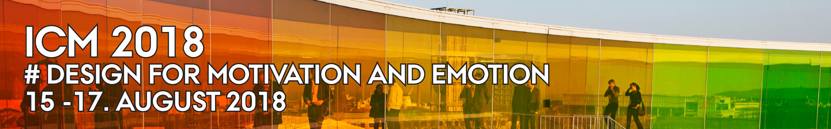

CALL FOR PAPERS
International Conference on Motivation (ICM) 2018 Aarhus University, Denmark

It is with great pleasure that we invite you to participate in the International Conference on Motivation (ICM) 2018, to be held 15-17 August in Aarhus, Denmark. The conference is jointly organized by EARLI SIG 8 and Aarhus University.

Conference theme
The conference theme is “Design for Motivation”. ICM 2018 seeks to contribute to a scientific understanding of motivation and emotion. By highlighting ideas and design principles which can be applied to improve motivation in teaching and learning settings, participants will be exposed to new and inspiring perspectives whether well-established at the forefront of motivational science or at the early stages of a research career.

Questions at the centre of the discussions and presentations at this conference include:
• How can we implement design principles for improving educational motivation?
• How can we empirically examine how such principles work and under which conditions?
• How do different design principles support or conflict with educational principles when implemented in the classroom?
• How do these principles foster student motivation and learning within and across diverse learning environments and student groups?

Keynote speakers
Professor Dr. Simone Volet, Murdoch University, Perth
Professor Dr. Sanna Järvelä, University of Oulu
Associate Professor Dr. Kou Murayama, University of Reading
Dr. Sebastian Deterding, University of York

Submission instructions
Please find attached to this email the submission instructions for ICM 2018.

Further information
http://conferences.au.dk/icm-2018/

SUMMER SCHOOL
Following an established tradition, the ICM 2018 will be preceded by a summer school for doctoral students interested in topics related to motivation and emotion from 12-14 August 2018.
The summer school teachers are:
- Thea Peetsma (University of Amsterdam)
- Markku Niemivirta (University of Helsinki)
- Sofia-Eleftheria Gonida (Aristotle University of Thessaloniki)
- Tina Hascher (University of Bern)
- Andreas Lieberoth (Aarhus University)
Further details will be published on the conference website and will be updated on a regular basis.
To participate in the 7th Summer School on Motivation and Emotion, PhD students are asked to submit proposals (about 1000 words) related to their doctoral research work. The deadline and criteria for submissions will be announced shortly.

We look forward to welcoming you in Aarhus!

The SIG 8 coordinators & The local organizing committee

Head of local organizing committee
Niels Bonderup Dohn, associate professor, Danish School of Education, Aarhus University
dohn@edu.au.dk

Practical questions can be addressed to:
Anette Eriksen, conference secretariat, Danish School of Education, Aarhus University
aeri@edu.au.dk

Student Research Excellence Recognition 2017
At the SIG 8 members meeting held at the EARLI 2017 conference, the “Student Research Excellence Recognition” was awarded to two graduate students, based on their outstanding first-authored papers presented at the conference.

The selected papers were:
Kyosuke Kakinuma, Doshisha University, Japan
Title: The Effect of Praise by Friends on Intrinsic Motivation
Supervisor: Ayumi Tanaka

Tim Post, University of Twente, The Netherlands
Title: Development and Validation of a Questionnaire to Measure Primary School Children’s Images of and Attitudes Towards Curiosity
Supervisor: Juliette Walma van der Molen

Their papers were selected based on the following criteria:
- Innovative ideas, research question(s) and/or methods used
- Methodological rigor
- Quality of the description of the theoretical contribution of the research, practical implications of the research, and/or the contribution of the research to practice

We congratulate them on this well-deserved recognition and wish them success as they advance their careers in the field of Motivation and Emotion research!

Kind regards,
Hanke Korpershoek and Fani Lauermann (SIG 8 Coordinators)
Kristina Loderer (SIG 8 JURE Assistant Coordinator)

